EDUCATIONAL ESSENTIALS LIMITED
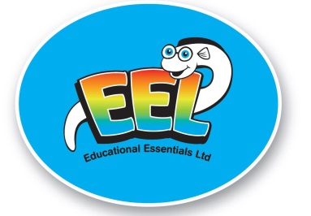
3/125 Kerrs Road, Manukau
P O Box 76312 Manukau City
Ph 09 267 2653 Fax 09 267 3827
E-Mail eduessltd@vodafone.co.nz
Website : educationalessentials.co.nz

Instructions for Browns Bay School online ordering

ALL Online School orders are delivered DIRECT TO THE SCHOOL for distribution to your child when school starts

PLEASE DO NOT REGISTER FOR AN ACCOUNT – SHOP AS A GUEST AS BELOW

ONE TRANSACTION PER STUDENT PLEASE IF MULTIPLE STUDENTS AT THE SCHOOL

- Go to educationalessentials.co.nz website
- Click on the Schools tab ( towards top right of screen)
- Enter in “Browns Bay School”
- Click on “Browns Bay School”
- Products available to order will now be shown
- Add the Product/Products required to your cart ( to add more than 1 product simply click the back arrow to go back to product page, items already ordered will stay in shopping cart). The EEL website also works on a breadcrumb trail so you can click back to any page visited.
- Click Checkout Tab ( Top Right of Screen)
- Click “Guest Checkout” - DO NOT REGISTER FOR AN ACCOUNT
- Click Continue and then - Fill in all details required
- Ensure you fill in e-mail address, phone number so we can contact you in case of a query
- DPS Payment express will ask for your credit card details for payment
- In Comments- enter the name of your Child (Student) and Room Number ( If known )
- Credit Card payments only are accepted on this site ( If you do not wish to pay by credit card there is a downloadable form under the Promotions Page where you can pay by direct banking )
- Any queries about your school pack ordered – either e-mail or call EEL but you must have your Confirmation number for EEL to be able to help you.

A confirmation of order will be sent to you and your child’s stationery will be delivered to the School for the start of the school term

If you have any problems ordering on the website an order form is also available under the Promotions section that may be e-mailed or faxed to EEL

**** This system is active all year long – any orders placed after back to school are still delivered direct to the School with your Child’s name on the pack

